Grade Kindergarten
The Sounds of Voices

Description: | Students use the Sound Recorder to:  Tell name, phone number, family’s names, and count to ten.  Recite a poem and paint a picture to go with it.  Tell a story they created or heard in class.  Report about something that happened yesterday.  Create a dialog or story with a partner so each part has its own sound recorder and the story can be heard in correct order.  Sing a song.  Describe what they see in a photo or by looking outside.
Project View | 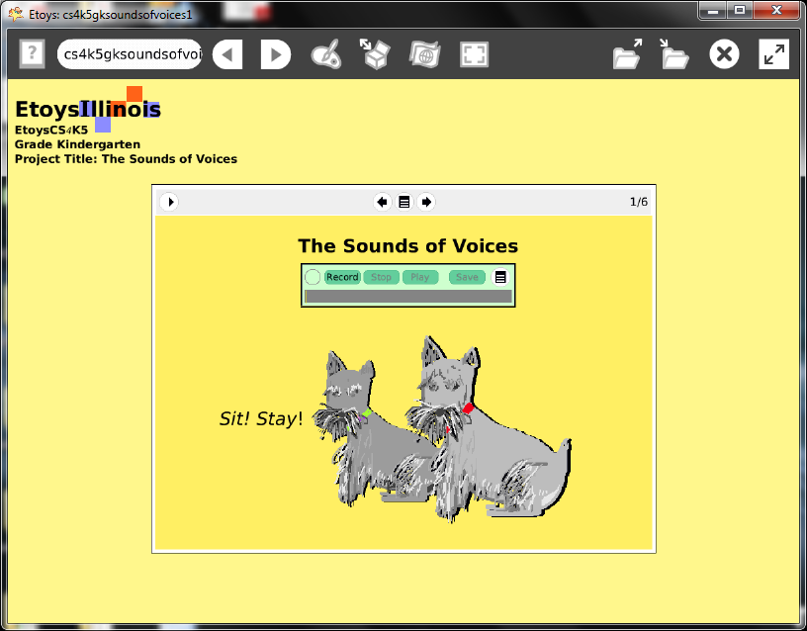
Subject: | Multi-media, Language Arts, Art, Math
Etoys Quick Guides | Click the question mark in Etoys to open the set of interactive tutorials for basic tools and techniques.
Vocabulary: | Record, Stop, Play, recite, tell, explain, relate, remember, discuss, imagine, create, say, speak
Lesson 1:  Supplies: Sound Recorder | These experiences will take several weeks for students to explore and to become confident. Give them many opportunities to record their ideas in a variety of purposes.  The project book’s ideas can be done in any order.  Show students how to open Etoys and click on Make a Project.  Show them how to open the Supplies flap to find a Sound Recorder. Their computer must be equipped with a microphone.  Click Record and speak, click Stop, and click Play to listen. Give students time to play with the sound recorder: counting saying the alphabet, making soft and loud noises, whispering, humming, and sound effects and other ideas based in current class topics.  Give students time to hear what they are saying and how they sound. Children have good ideas that they cannot write yet or sometimes can’t articulate during a fast paced lesson. The tool gives them time to think, to tell, to review, and to revise.
Standards: | Common Core Standards  Mathematics: K.CC 1, 3  Language Arts: K.SL 4,5,6  Bloom’s Taxonomy/Cognitive Domain:  Knowledge: describes, knows, names, selects, states  Application: produces, uses  NETS  1. a, b  2. a, b, d  4. b  5. b
Resources: | Etoys Help Quick Guides: always available in Etoys. Open Etoys and click the question mark to open a set of interactive tutorials of basic tools and techniques.  www.EtoysIllinois.org projects, lesson plans, software download  www.MSTE.Illinois.org math, science, and technology resources  www.corestandards.org Common Core Standards  www.Squeakland.org software and Etoys projects  www.nctm.org Standards and Focal Points for each grade level
kh
January 2011

